**MIDDLETON CHENEY FOOTBALL CLUB**

**ANNUAL GENERAL MEETING**

**1991**

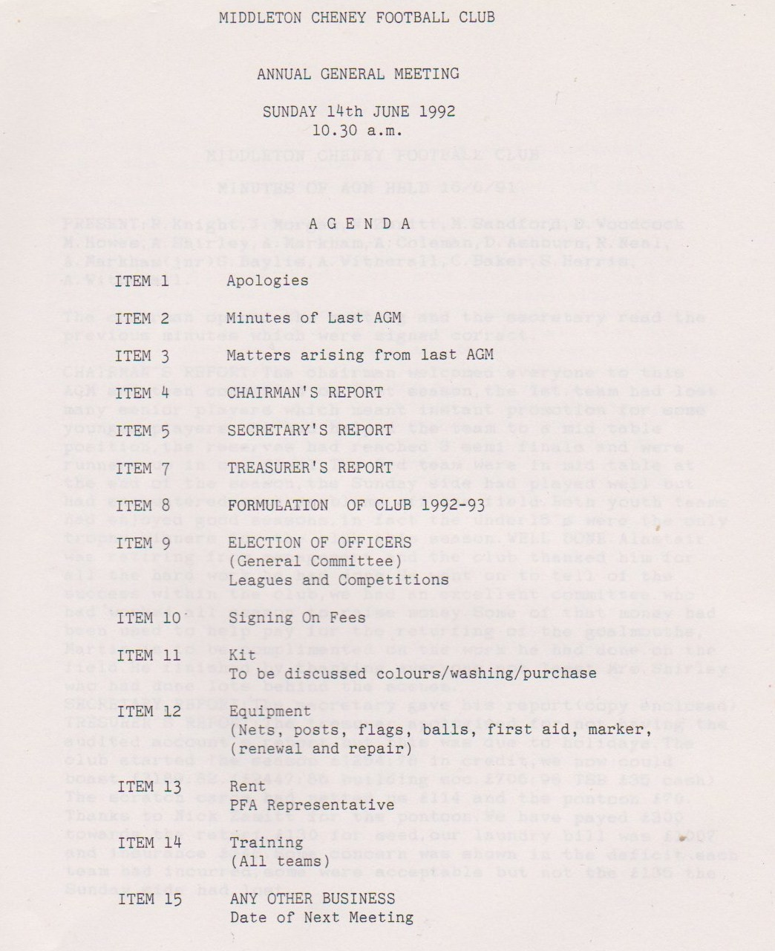

**Continued**

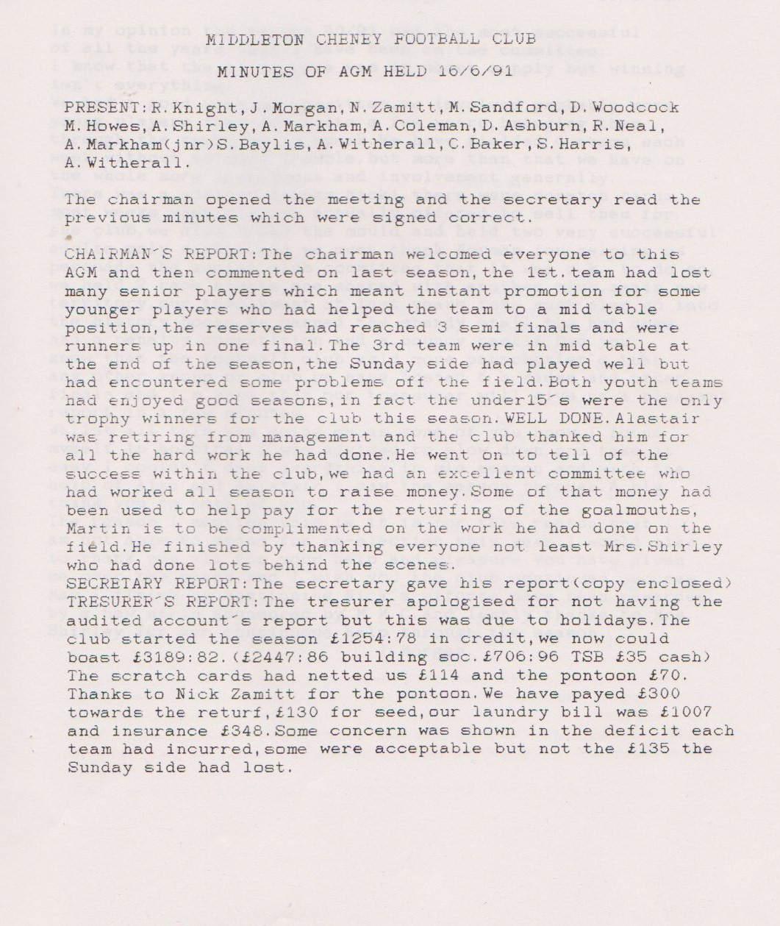

**Continued**

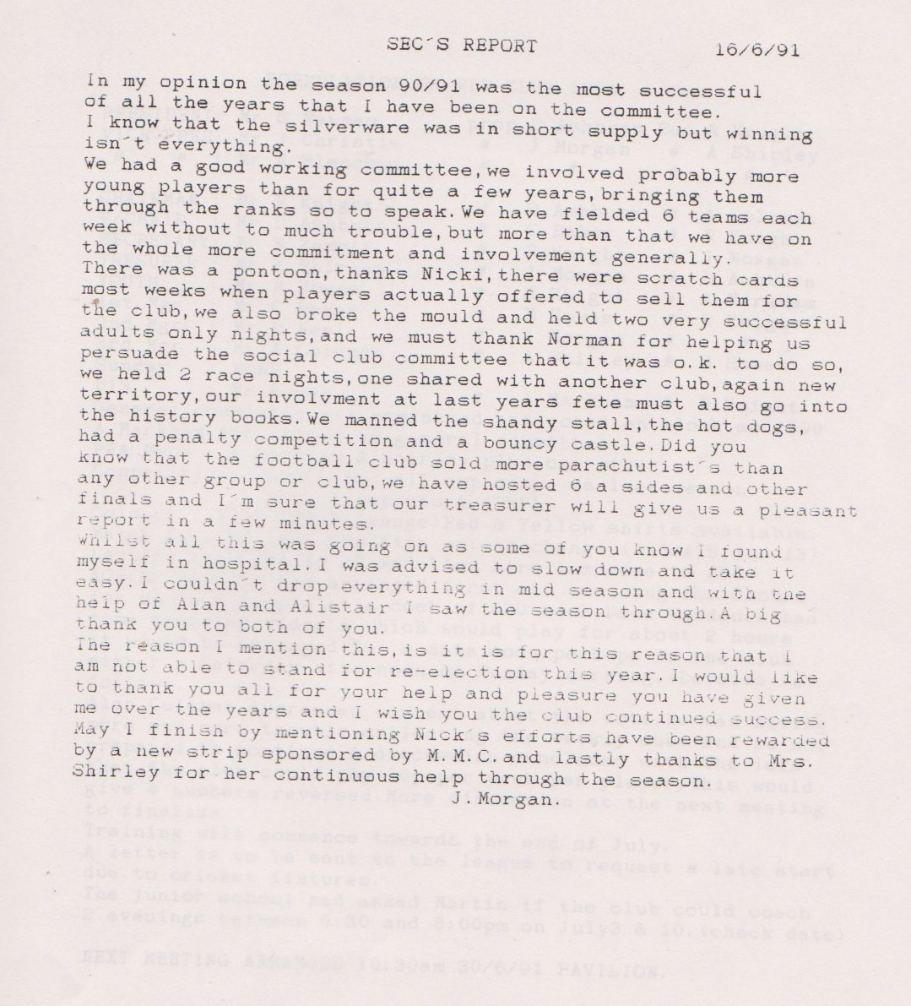

**Continued**

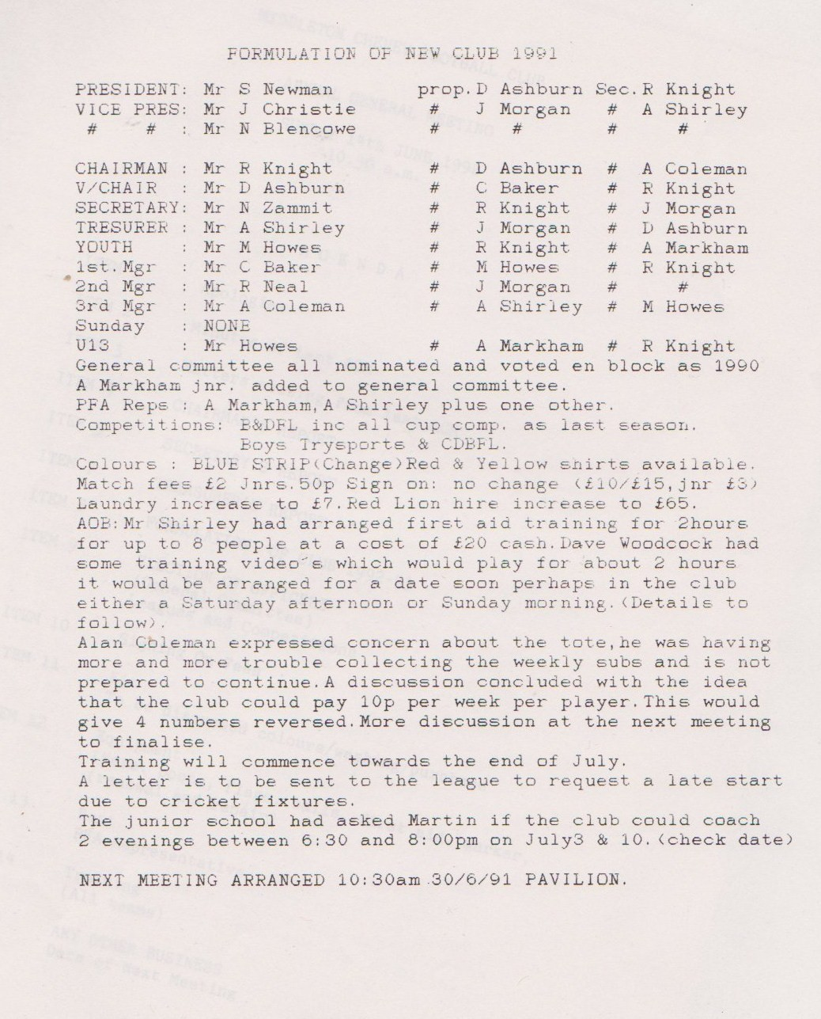

**General Committee Meeting**

**June 30th 1991**

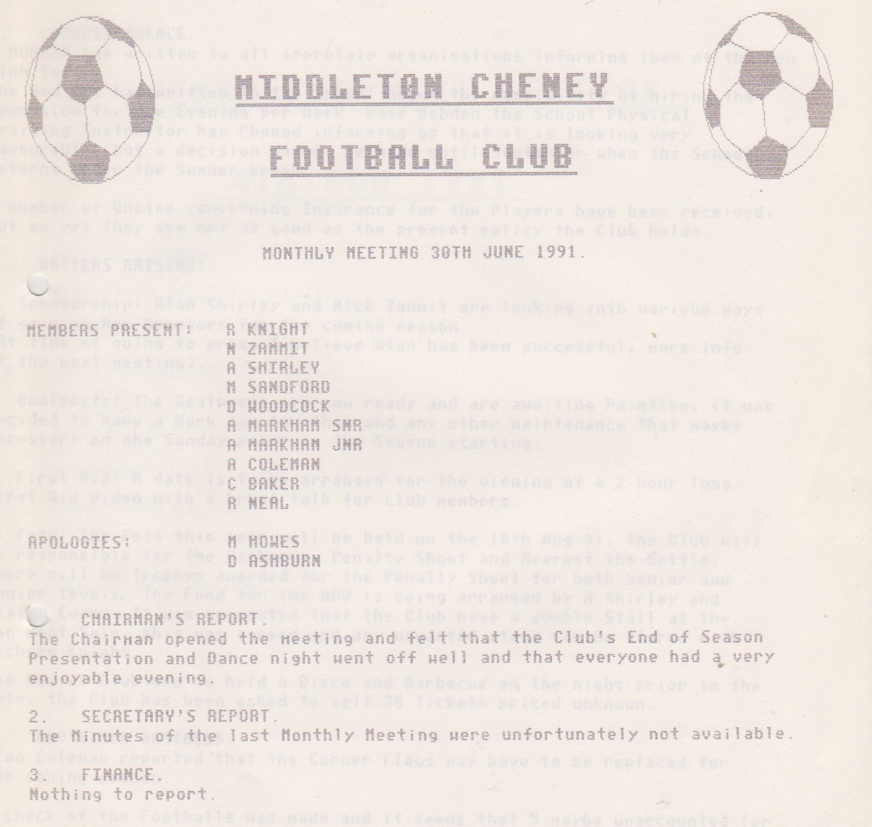

**Continued**

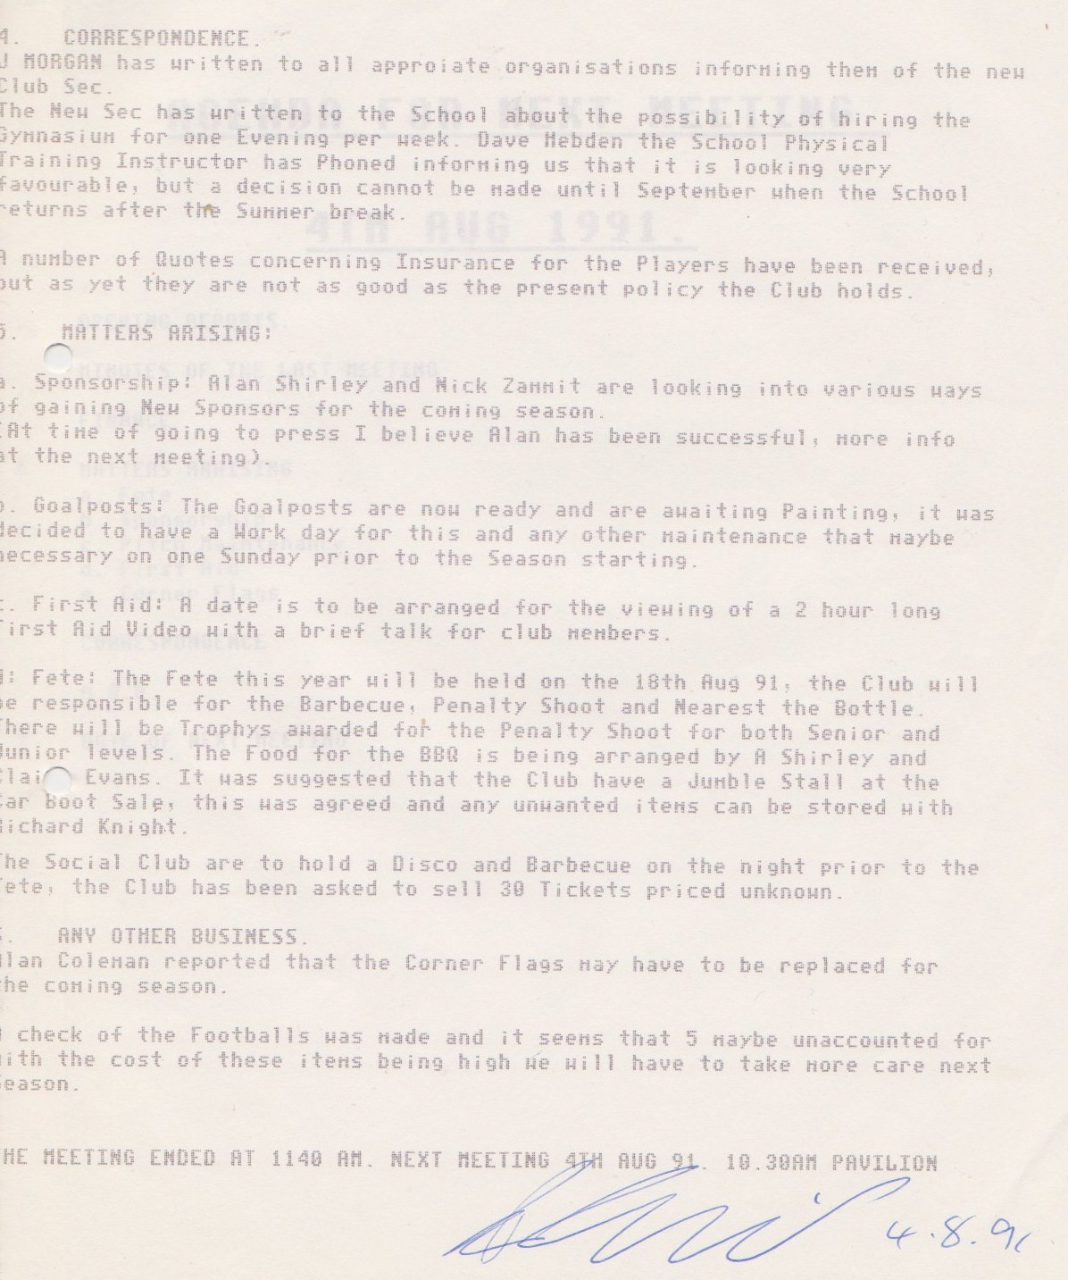

**General Committee Meeting**

**August 4th 1991**

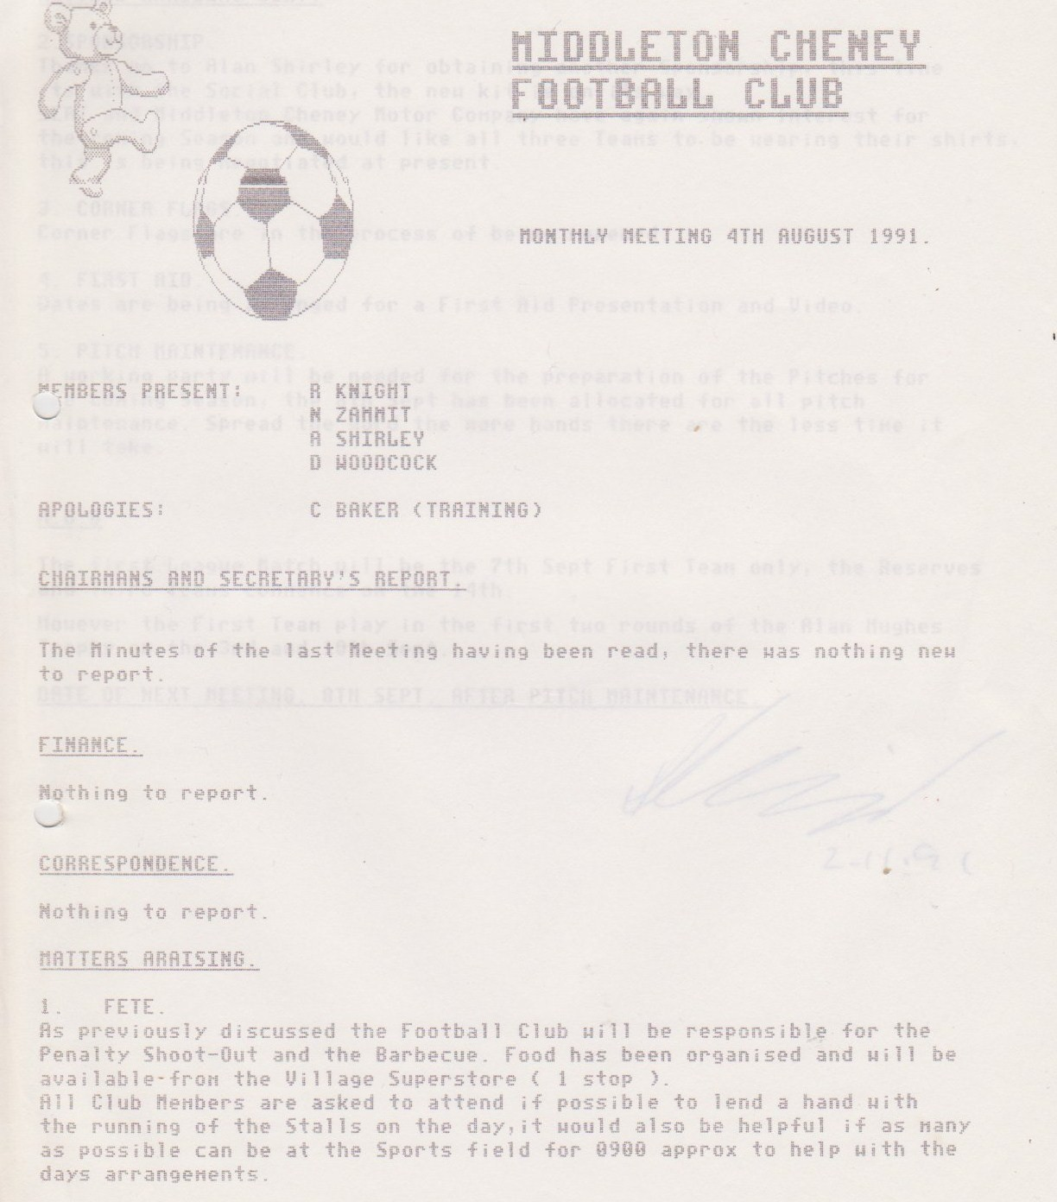

**Continued**

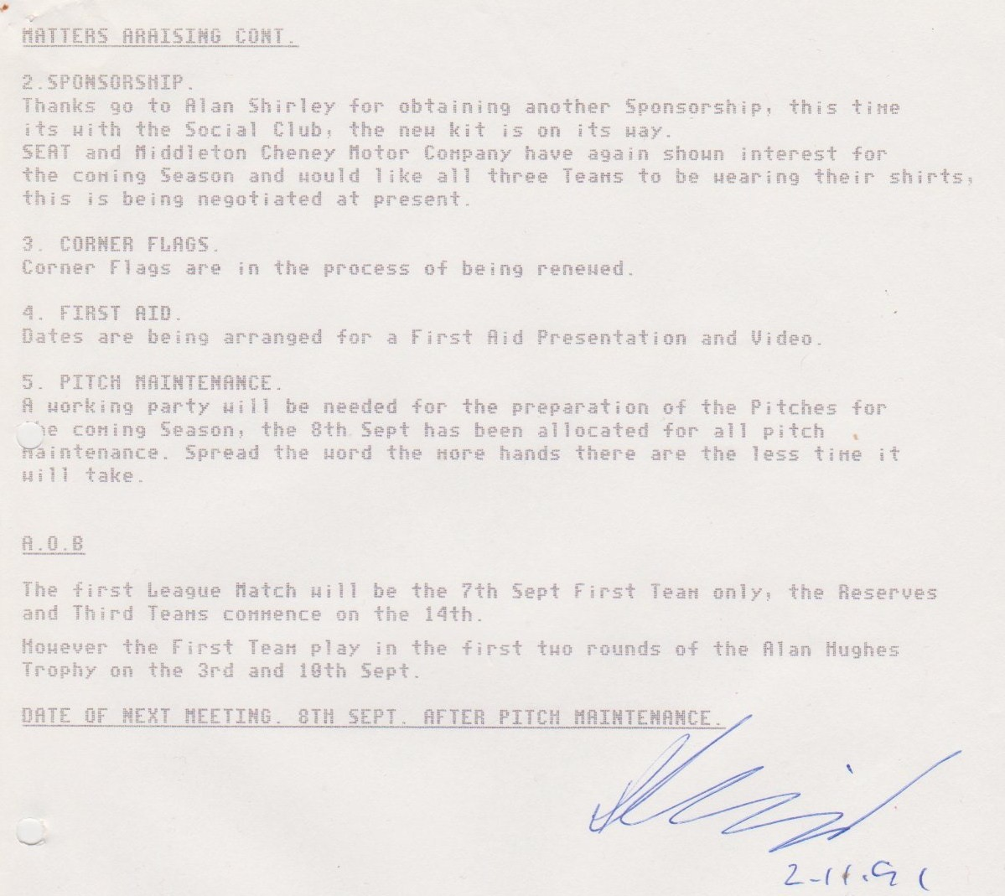

**General Committee Meeting**

**October 5th 1991**

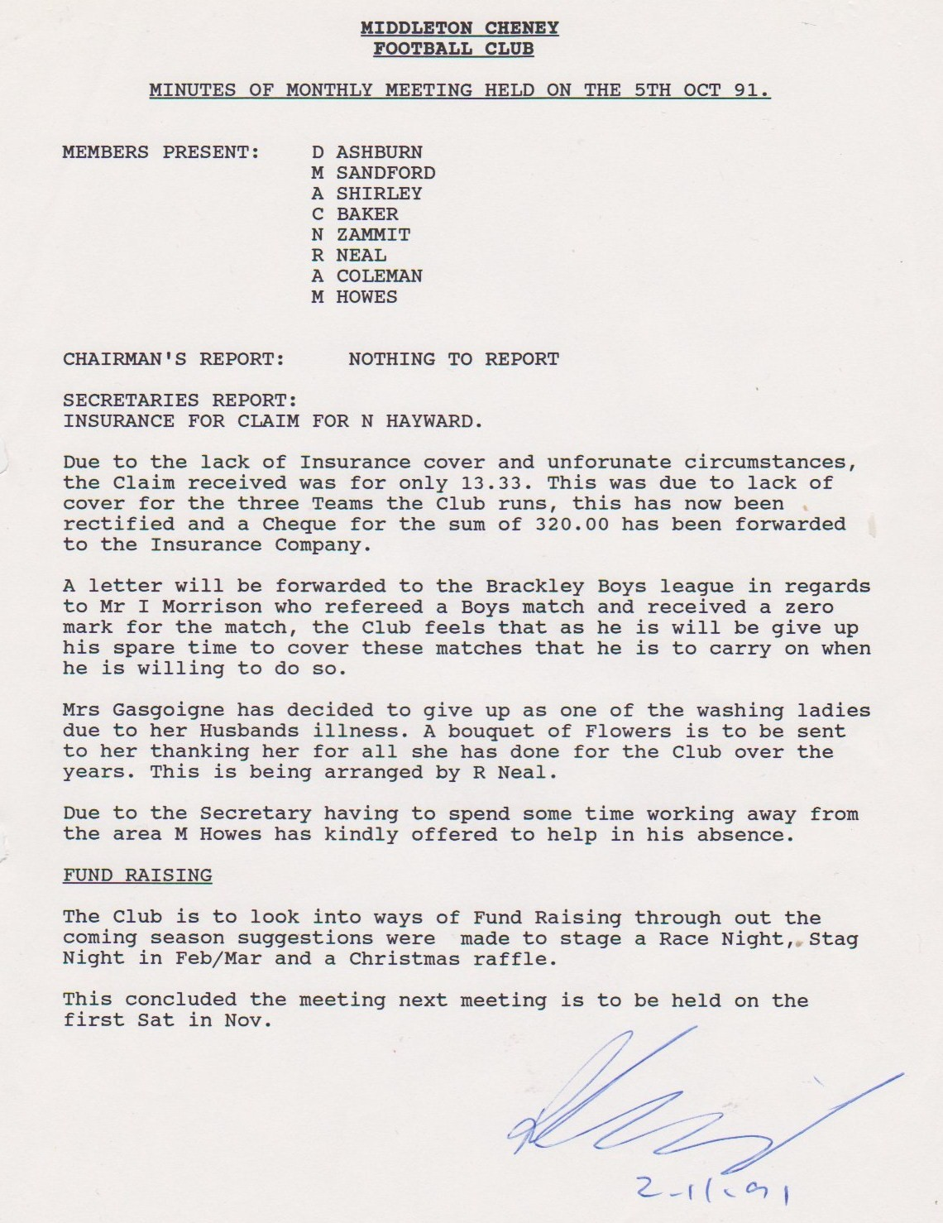

**General Committee Meeting**

**November 2nd 1991**

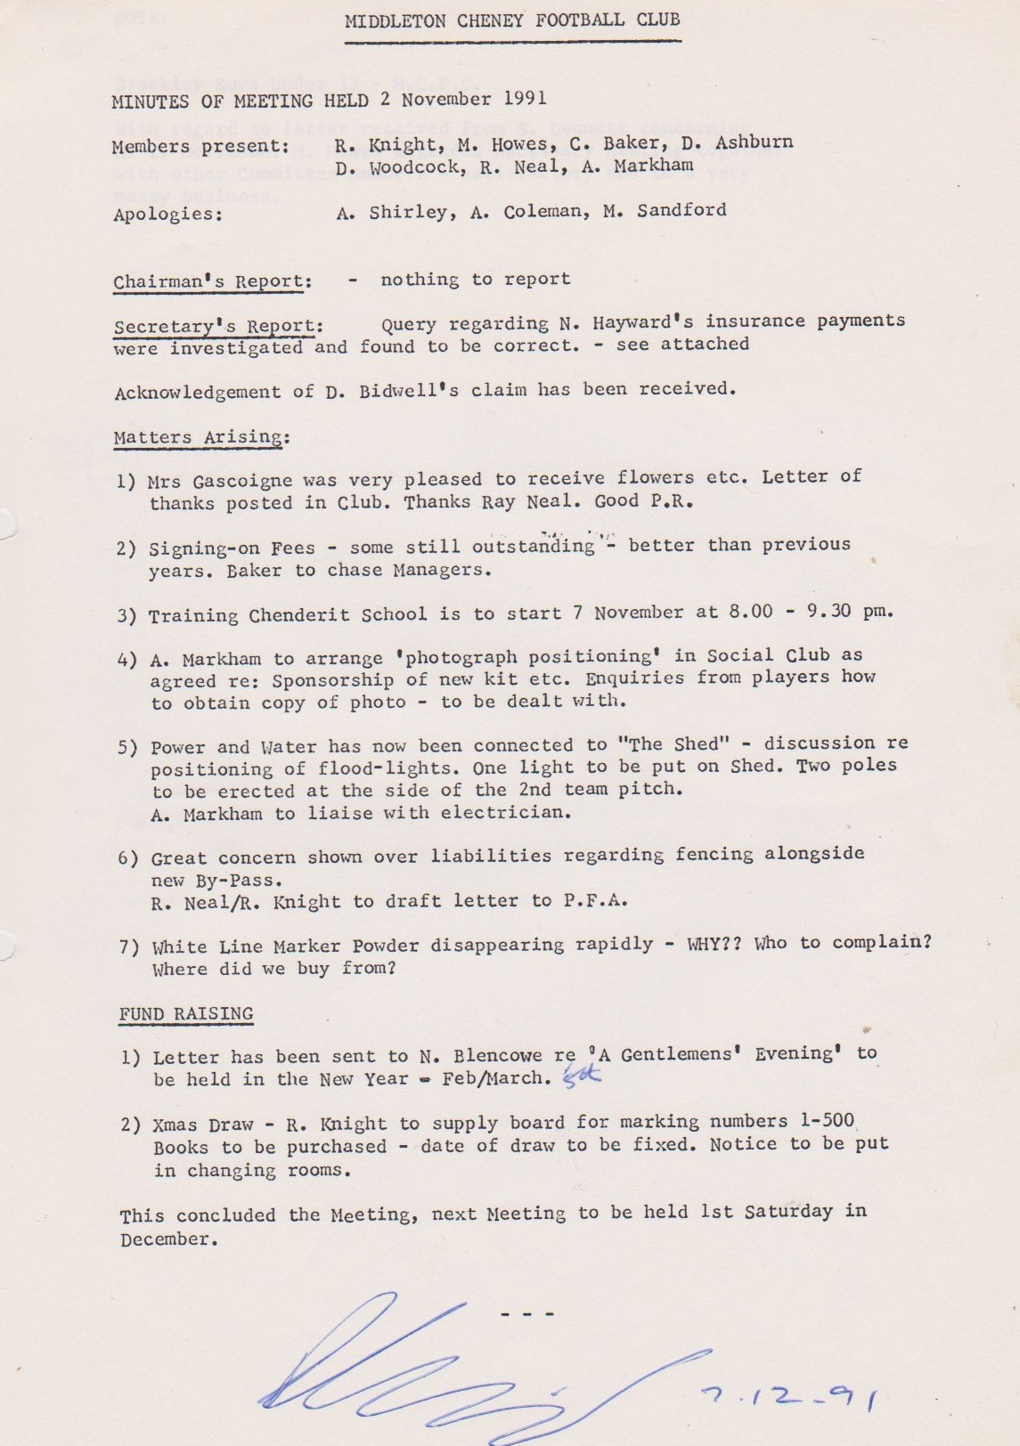

**General Committee Meeting**

**December 7th 1991**

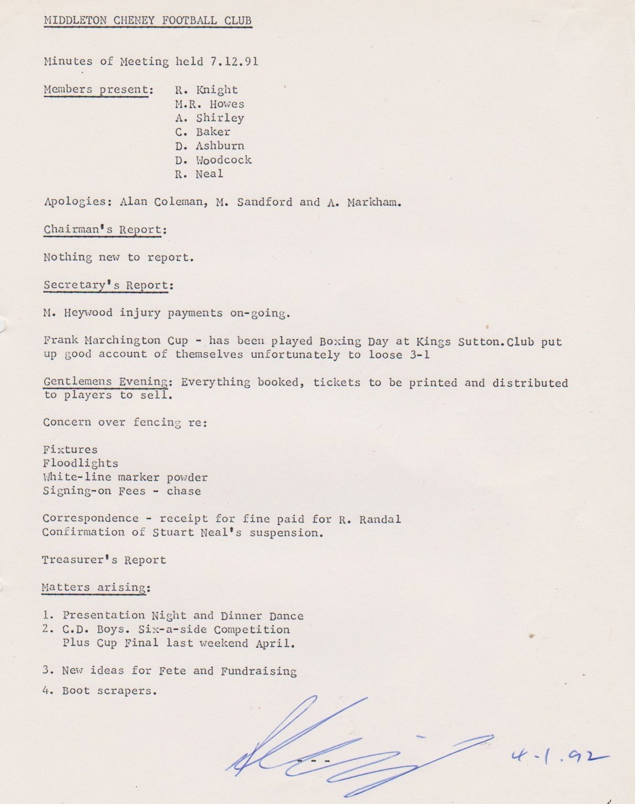

**General Committee Meeting**

**January 4th 1992**

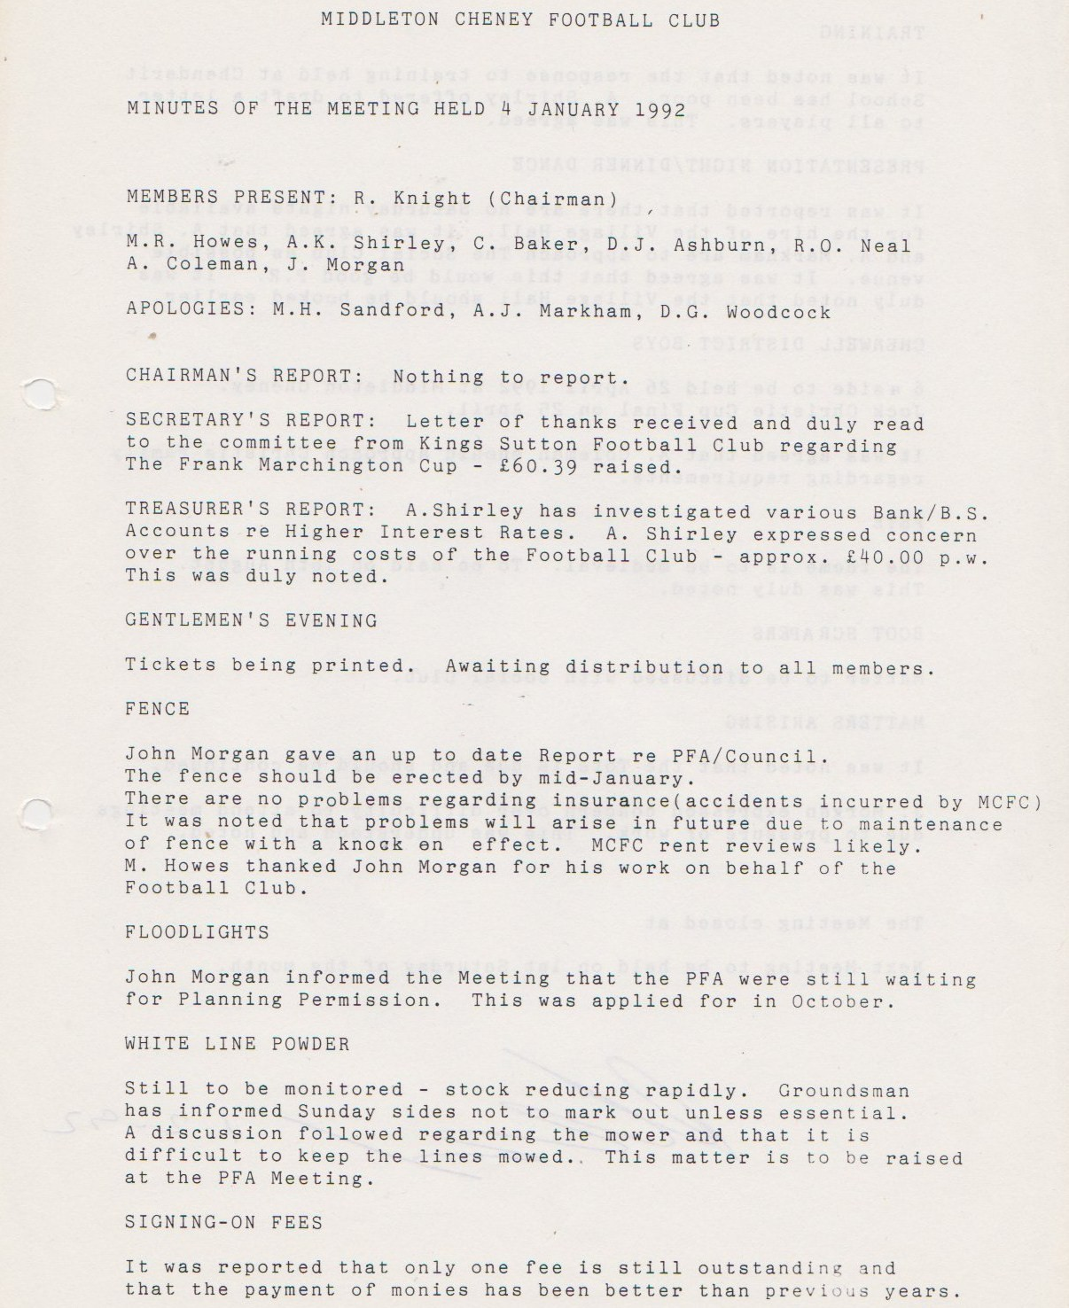

**Continued**

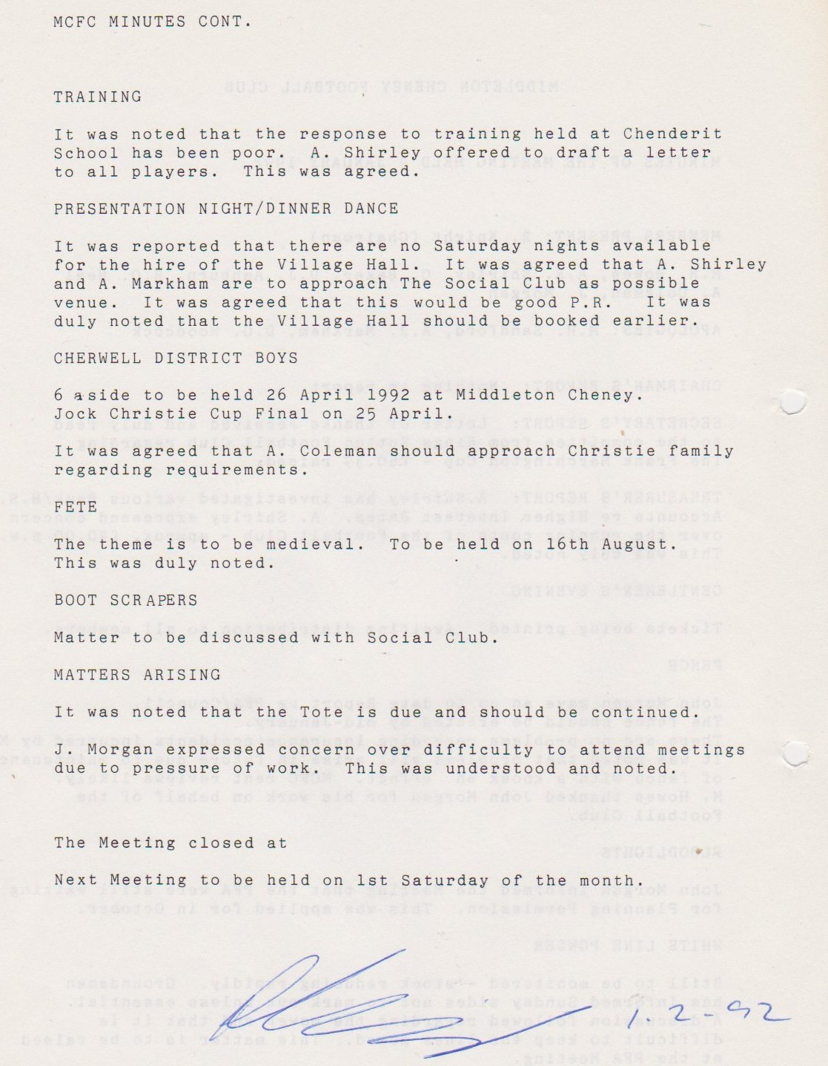

**General Committee Meeting**

**February 1st 1992**

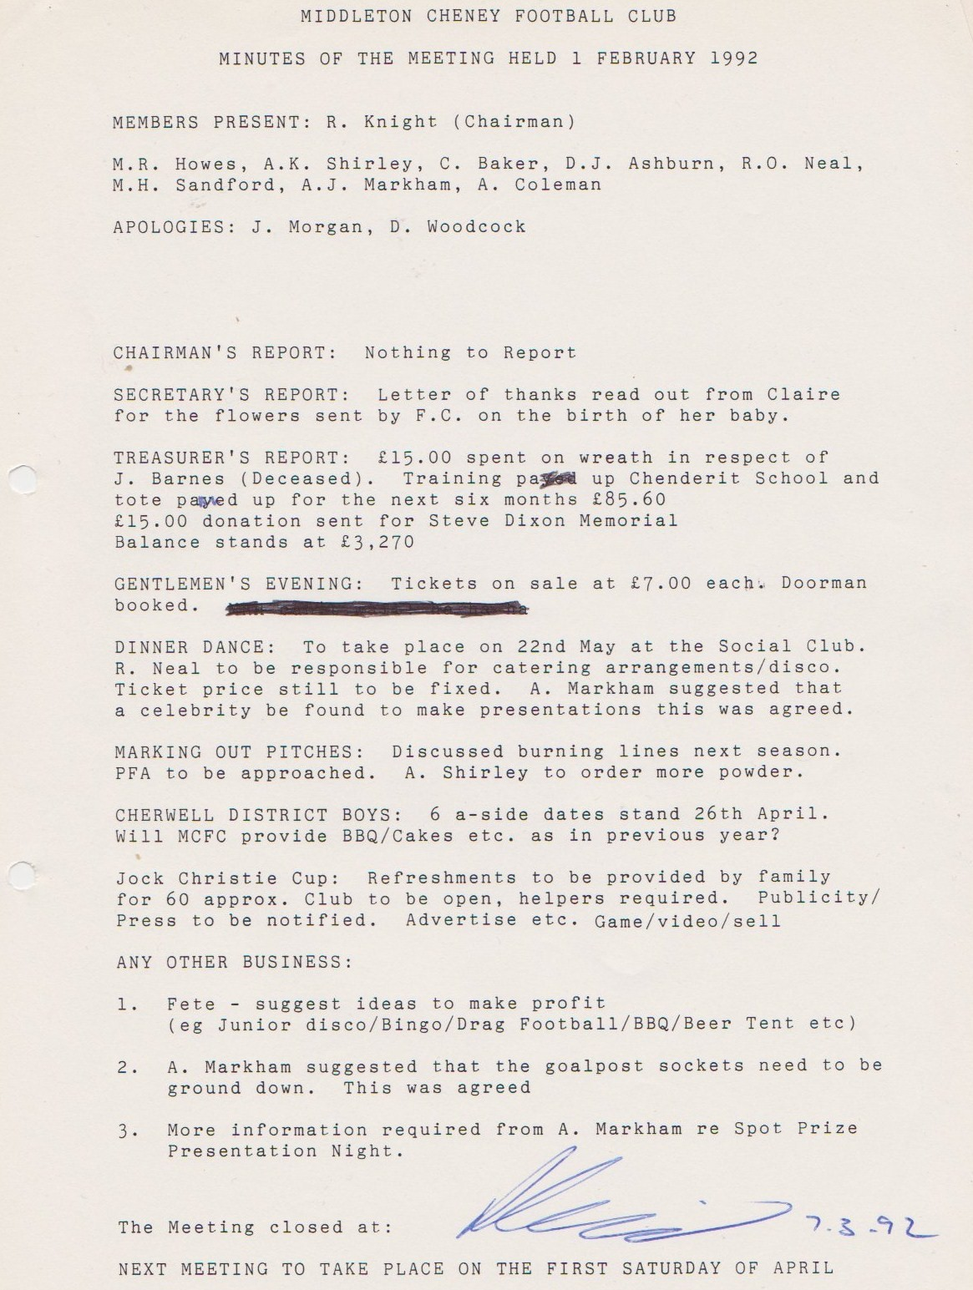

**General Committee Meeting**

**March 7th 1992**

